|  |  |
| --- | --- |
|  | **SREE NARAYANA GURUKULAM**  **COLLEGE OF ENGINEERING**  **KADAYIRUPPU, KOLENCHERY 682311** |

**---------------------------------------**

**LABORATORY RECORD**

**YEAR:** 2022  **TO**  2023

**NAME:** NISHAN

**SEMESTER:** 3 **ROLL NO:** 24

**BRANCH:** COMPUTER APPLICATIONS

Certified that this is a Bonafide Record of Practical work done in partial fulfillment of the requirements for the award of the Degree in Master of Computer Applications of Sree Narayana Gurukulam College of Engineering.

Kadayiruppu

Date:

Head of the Department Course Instructor

Submitted for University Practical Examination

**Reg. No:** SNG21MCA-2026 **on**

External Examiner Internal Examiner

**INDEX PAGE**

|  |  |  |
| --- | --- | --- |
| **NO** | **PROGRAM** | **DATE** |
| **COURSE OUTCOME 1** | | |
| 1 | LOGIN FORM | 30/08/22 |
| 2 | ACTIVITY LIFECYCLE | 03/09/22 |
| 3 | SIMPLE CALCULATOR | 10/09/22 |
| 4 | FORM VALIDATION | 20/09/22 |
| **COURSE OUTCOME 2** | | |
| 5 | INTENT AND SHARED PREFERENCES | 25/09/22 |
| 6 | GRID CALCULATOR | 30/09/22 |
| 7 | FACEBOOK PAGE | 05/10/22 |
| 8 | TOGGLE IMAGE | 20/10/22 |
| **COURSE OUTCOME 3** | | |
| 9 | INTENT | 30/10/22 |
| 10 | MENU | 10/11/22 |
| **COURSE OUTCOME 5** | | |
| 11 | DATABASE MANAGEMENT | 20/11/22 |

**COURSE OUTCOME 1**

**PROGRAM NO:**1

**DATE:** 30/08/22

**LOGIN FORM**

**AIM**

Design a Login Form with username and password using LinearLayout and toast valid credentials

**XML CODE**

*<?*xml version="1.0" encoding="utf-8"*?>*<androidx.constraintlayout.widget.ConstraintLayout  
 xmlns:android="http://schemas.android.com/apk/res/android"  
 xmlns:app="http://schemas.android.com/apk/res-auto"  
 xmlns:tools="http://schemas.android.com/tools"  
 android:layout_width="match_parent"  
 android:layout_height="match_parent"  
 tools:context=".MainActivity">  
 <LinearLayout  
 android:layout_width="409dp"  
 android:layout_height="729dp"  
 android:orientation="vertical"  
 tools:layout_editor_absoluteX="1dp"  
 tools:layout_editor_absoluteY="1dp"  
 tools:ignore="MissingConstraints">  
 <TextView  
 android:id="@+id/textView5"  
 android:layout_width="match_parent"  
 android:layout_height="37dp"  
 android:text="USERNAME"  
 android:textSize="20dp"/>  
 <EditText  
 android:id="@+id/txt_uname"  
 android:layout_width="match_parent"  
 android:layout_height="wrap_content"  
 android:ems="10"  
 android:hint="user name"  
 android:inputType="textPersonName" />  
 <TextView  
 android:id="@+id/textView6"  
 android:layout_width="match_parent"  
 android:layout_height="35dp"  
 android:text="PASSWORD"  
 android:textSize="20dp"/>  
 <EditText  
 android:id="@+id/txt_pwd"  
 android:layout_width="match_parent"  
 android:layout_height="wrap_content"  
 android:ems="10"  
 android:hint="password"  
 android:inputType="textPassword" />  
 <Button  
 android:id="@+id/btn_login"  
 android:layout_width="match_parent"  
 android:layout_height="wrap_content"  
 android:background="#1B0000"  
 android:onClick="login_user"  
 android:text="LOGIN" />  
 </LinearLayout>  
</androidx.constraintlayout.widget.ConstraintLayout>

**JAVA CODE**

package com.example.login_form;  
  
import androidx.appcompat.app.AppCompatActivity;  
  
import android.os.Bundle;  
import android.view.View;  
import android.widget.Button;  
import android.widget.EditText;  
import android.widget.Toast;  
  
public class MainActivity extends AppCompatActivity {  
 EditText EditUser,EditPass;  
 Button BtnLogin;  
  
 @Override  
 protected void onCreate(Bundle savedInstanceState) {  
 super.onCreate(savedInstanceState);  
 setContentView(R.layout.*activity_main*);  
  
 EditUser=findViewById(R.id.*txt_uname*);  
 EditPass=findViewById(R.id.*txt_pwd*);  
 BtnLogin=findViewById(R.id.*btn_login*);  
 }  
  
 public void login_user(View view) {  
 String s1=EditUser.getText().toString();  
 String s2=EditPass.getText().toString();  
 if (s1.equals("Nishan") && s2.equals("nishu"))  
 {  
 Toast.*makeText*(this, "Login Successful", Toast.*LENGTH_SHORT*).show();  
 }  
 else  
 {  
 Toast.*makeText*(this, "Invalid Username or Password", Toast.*LENGTH_SHORT*).show();  
 }  
 }  
}

**OUTPUT**

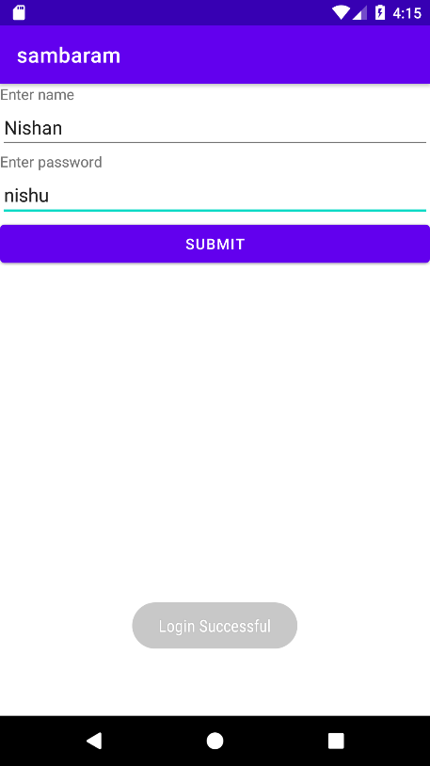

**PROGRAM NO:**2

**DATE:** 03/09/22

**ACTIVITY LIFECYCLE**

**AIM**

Write a program that demonstrates Activity Lifecycle.

**XML CODE**

*<?*xml version="1.0" encoding="utf-8"*?>*<androidx.constraintlayout.widget.ConstraintLayout xmlns:android="http://schemas.android.com/apk/res/android"  
 xmlns:app="http://schemas.android.com/apk/res-auto"  
 xmlns:tools="http://schemas.android.com/tools"  
 android:layout_width="match_parent"  
 android:layout_height="match_parent"  
 android:background="#020522"  
 tools:context=".MainActivity">  
  
 <TextView  
 android:layout_width="wrap_content"  
 android:layout_height="wrap_content"  
 android:background="#020522"  
 android:text="Hello World!"  
 android:textColor="#FFFFFF"  
 app:layout_constraintBottom_toBottomOf="parent"  
 app:layout_constraintEnd_toEndOf="parent"  
 app:layout_constraintStart_toStartOf="parent"  
 app:layout_constraintTop_toTopOf="parent" />  
  
</androidx.constraintlayout.widget.ConstraintLayout>

**JAVA CODE**

package com.example.lifecycle;  
  
import androidx.appcompat.app.AppCompatActivity;  
  
import android.os.Bundle;  
import android.widget.Toast;  
  
public class MainActivity extends AppCompatActivity {  
  
 @Override  
 protected void onCreate(Bundle savedInstanceState) {  
 super.onCreate(savedInstanceState);  
 setContentView(R.layout.*activity_main*);  
 Toast.*makeText*(this,"onCreate", Toast.*LENGTH_LONG*).show();  
 }  
 @Override  
 protected void onStart() {  
 super.onStart();  
 Toast.*makeText*(this,"onStart",Toast.*LENGTH_LONG*).show();  
 }  
 @Override  
 protected void onResume() {  
 super.onResume();  
 Toast.*makeText*(this,"onResume",Toast.*LENGTH_LONG*).show();  
 }  
 @Override  
 protected void onPause() {  
 super.onPause();  
 Toast.*makeText*(this,"onPause",Toast.*LENGTH_LONG*).show();  
 }  
 @Override  
 protected void onStop() {  
 super.onStop();  
 Toast.*makeText*(this,"onStop",Toast.*LENGTH_LONG*).show();  
 }  
 @Override  
 protected void onDestroy() {  
 super.onDestroy();  
 Toast.*makeText*(this,"onDestroy",Toast.*LENGTH_LONG*).show();  
 }  
}

**OUTPUT**

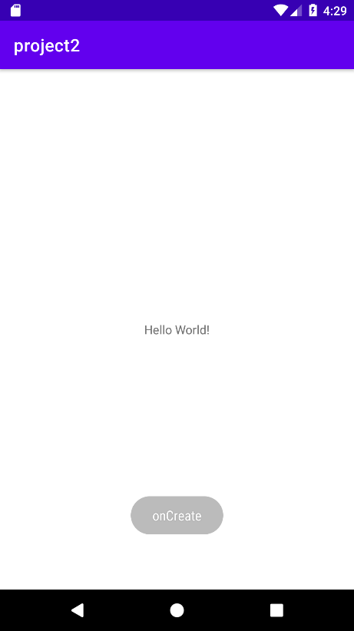 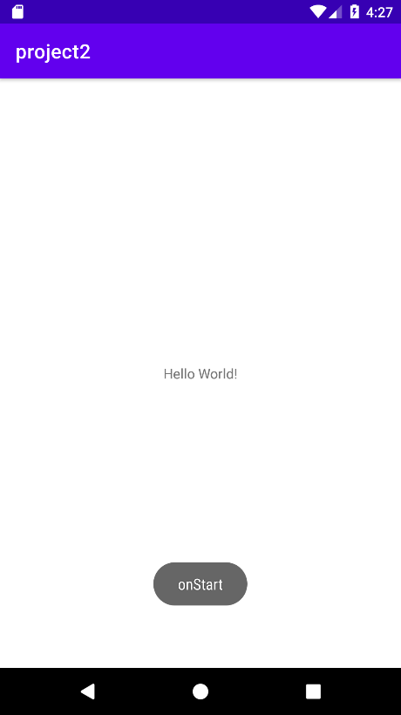

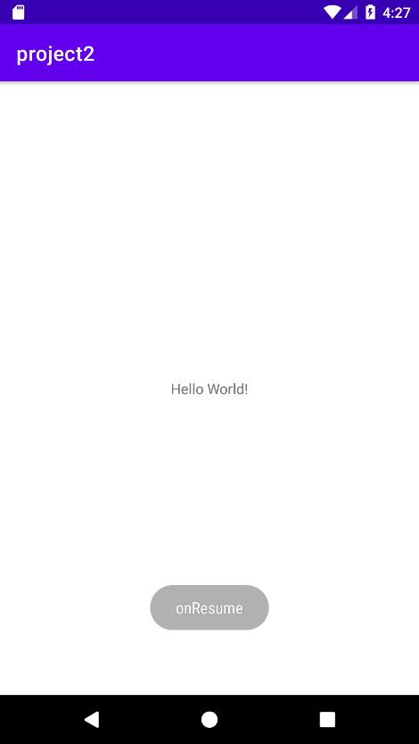

**PROGRAM NO:**3

**DATE:** 10/09/22

**SIMPLE CALCULATOR**

**AIM**

Implementing basic arithmetic operations of a simple calculator.

**XML CODE**

*<?*xml version="1.0" encoding="utf-8"*?>*<androidx.constraintlayout.widget.ConstraintLayout xmlns:android="http://schemas.android.com/apk/res/android"  
 xmlns:app="http://schemas.android.com/apk/res-auto"  
 xmlns:tools="http://schemas.android.com/tools"  
 android:layout_width="match_parent"  
 android:layout_height="match_parent"  
 tools:context=".MainActivity">  
   
 <LinearLayout  
 android:layout_width="409dp"  
 android:layout_height="729dp"  
 android:orientation="vertical"  
 tools:layout_editor_absoluteX="1dp"  
 tools:layout_editor_absoluteY="1dp"  
 tools:ignore="MissingConstraints">  
  
 <LinearLayout  
 android:layout_width="match_parent"  
 android:layout_height="77dp"  
 android:orientation="horizontal">  
  
 <TextView  
 android:id="@+id/textView3"  
 android:layout_width="97dp"  
 android:layout_height="wrap_content"  
 android:layout_weight="1"  
 android:text="EnterNumber 1" />  
  
 <EditText  
 android:id="@+id/n1"  
 android:layout_width="wrap_content"  
 android:layout_height="wrap_content"  
 android:layout_weight="1"  
 android:ems="10"  
 android:inputType="textPersonName" />  
 </LinearLayout>  
  
 <LinearLayout  
 android:layout_width="match_parent"  
 android:layout_height="65dp"  
 android:orientation="horizontal">  
  
 <TextView  
 android:id="@+id/textView7"  
 android:layout_width="wrap_content"  
 android:layout_height="wrap_content"  
 android:layout_weight="1"  
 android:text="Enter Number 2" />  
  
 <EditText  
 android:id="@+id/n2"  
 android:layout_width="wrap_content"  
 android:layout_height="wrap_content"  
 android:layout_weight="1"  
 android:ems="10"  
 android:inputType="textPersonName" />  
 </LinearLayout>  
 <LinearLayout  
 android:layout_width="match_parent"  
 android:layout_height="91dp"  
 android:orientation="horizontal">  
  
 <Button  
 android:id="@+id/submit_btn"  
 android:layout_width="match_parent"  
 android:layout_height="wrap_content"  
 android:layout_weight="1"  
 android:onClick="sum"  
 android:text="Sum" />  
 </LinearLayout>  
 <LinearLayout  
 android:layout_width="match_parent"  
 android:layout_height="78dp"  
 android:orientation="horizontal">  
  
 <TextView  
 android:id="@+id/textView8"  
 android:layout_width="98dp"  
 android:layout_height="wrap_content"  
 android:layout_weight="1"  
 android:text="Result" />  
  
 <EditText  
 android:id="@+id/result"  
 android:layout_width="wrap_content"  
 android:layout_height="wrap_content"  
 android:layout_weight="1"  
 android:ems="10"  
 android:inputType="textPersonName" />  
 </LinearLayout>  
 </LinearLayout>  
</androidx.constraintlayout.widget.ConstraintLayout>

**JAVA CODE**

package com.example.calculator;  
  
import androidx.appcompat.app.AppCompatActivity;  
  
import android.os.Bundle;  
import android.view.View;  
import android.widget.Button;  
import android.widget.EditText;  
  
public class MainActivity extends AppCompatActivity {  
 EditText et_first,et_second,et_result;  
 Button et_submit;  
  
 @Override  
 protected void onCreate(Bundle savedInstanceState) {  
 super.onCreate(savedInstanceState);  
 setContentView(R.layout.*activity_main*);  
 et_first=findViewById(R.id.*n1*);  
 et_second=findViewById(R.id.*n2*);  
 et_result=findViewById(R.id.*result*);  
 et_submit=findViewById(R.id.*submit_btn*);  
 }  
 public void sum(View view){  
 int num1 = Integer.*parseInt*(et_first.getText().toString());  
 int num2 = Integer.*parseInt*(et_second.getText().toString());  
 int sum = num1+num2;  
 et_result.setText(sum+"");  
 }  
}

**OUTPUT**

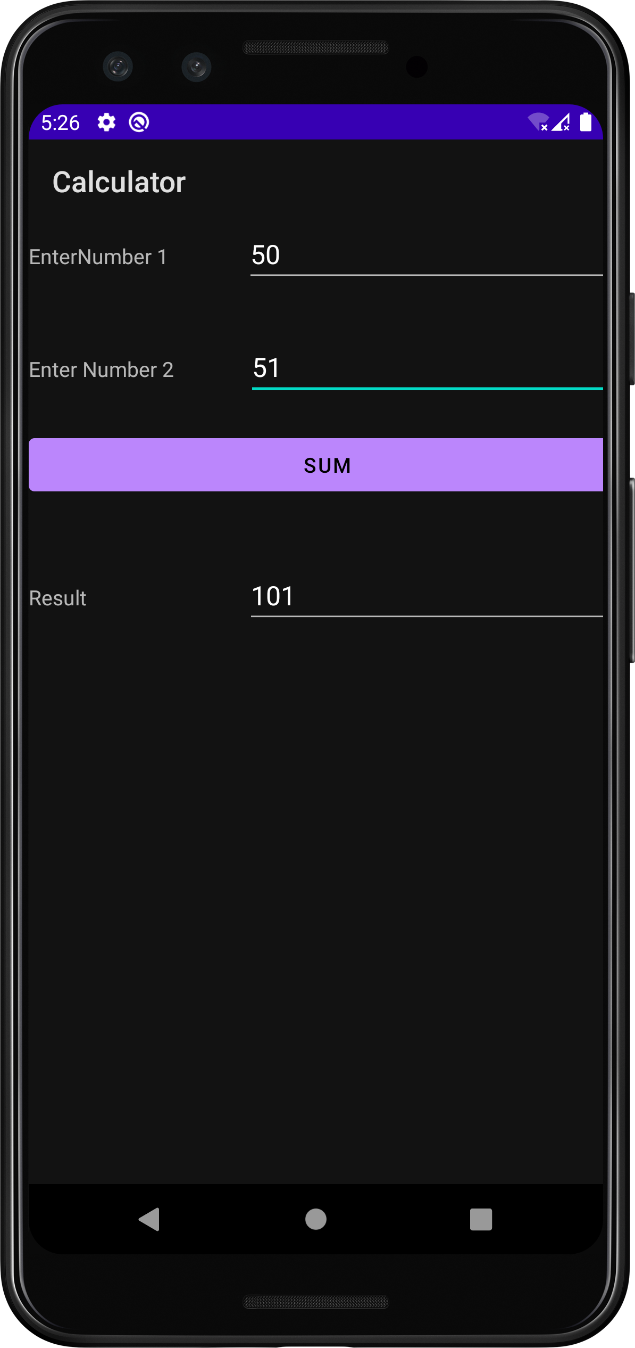

**PROGRAM NO:**4

**DATE:** 20/09/22

**FORM VALIDATION**

**AIM**

Implement validations on various UI controls.

**XML CODE**

<?xml version="1.0" encoding="utf-8"?>

<LinearLayout xmlns:android="http://schemas.android.com/apk/res/android"

xmlns:app="http://schemas.android.com/apk/res-auto"

xmlns:tools="http://schemas.android.com/tools"

android:id="@+id/linearLayout"

android:layout_width="match_parent"

android:layout_height="match_parent"

android:orientation="vertical"

tools:context=".MainActivity">

<LinearLayout

android:layout_width="match_parent"

android:layout_height="55dp"

android:orientation="horizontal">

<TextView

android:id="@+id/textView6"

android:layout_width="match_parent"

android:layout_height="57dp"

android:background="#0000FF"

android:text="Enter the details for reg"

android:textAlignment="center"

android:textSize="25dp" />

</LinearLayout>

<LinearLayout

android:layout_width="match_parent"

android:layout_height="65dp"

android:orientation="horizontal">

<EditText

android:id="@+id/editTextTextPersonName6"

android:layout_width="wrap_content"

android:layout_height="wrap_content"

android:layout_weight="1"

android:ems="10"

android:hint="First Name"

android:inputType="textPersonName"

android:minHeight="48dp" />

<EditText

android:id="@+id/editTextTextPersonName7"

android:layout_width="wrap_content"

android:layout_height="wrap_content"

android:layout_weight="1"

android:ems="10"

android:hint="Last Name"

android:inputType="textPersonName"

android:minHeight="48dp" />

</LinearLayout>

<LinearLayout

android:layout_width="match_parent"

android:layout_height="82dp"

android:orientation="horizontal">

<EditText

android:id="@+id/editTextTextEmailAddress"

android:layout_width="match_parent"

android:layout_height="120dp"

android:ems="10"

android:hint="enter email"

android:inputType="textEmailAddress" />

</LinearLayout>

<LinearLayout

android:layout_width="match_parent"

android:layout_height="89dp"

android:orientation="horizontal">

<RadioGroup

android:id="@+id/radioo"

android:layout_width="match_parent"

android:layout_height="87dp"

android:orientation="horizontal">

<RadioButton

android:id="@+id/radioButton9"

android:layout_width="wrap_content"

android:layout_height="wrap_content"

android:layout_weight="1"

android:text="Male" />

<RadioButton

android:id="@+id/radioButton10"

android:layout_width="wrap_content"

android:layout_height="wrap_content"

android:layout_weight="1"

android:text="Female" />

<RadioButton

android:id="@+id/radioButton11"

android:layout_width="wrap_content"

android:layout_height="wrap_content"

android:layout_weight="1"

android:text="Other" />

</RadioGroup>

</LinearLayout>

<LinearLayout

android:layout_width="match_parent"

android:layout_height="67dp"

android:orientation="horizontal">

<EditText

android:id="@+id/editTextDate"

android:layout_width="wrap_content"

android:layout_height="wrap_content"

android:layout_weight="1"

android:ems="10"

android:hint="Date of Birth"

android:inputType="date"

android:minHeight="48dp" />

<TextView

android:id="@+id/textView7"

android:layout_width="wrap_content"

android:layout_height="wrap_content"

android:layout_weight="1"

android:text="Select Date" />

</LinearLayout>

<LinearLayout

android:layout_width="match_parent"

android:layout_height="65dp"

android:orientation="vertical">

<EditText

android:id="@+id/editTextTextPassword"

android:layout_width="match_parent"

android:layout_height="wrap_content"

android:ems="10"

android:hint="enter password"

android:inputType="textPassword"

android:minHeight="48dp" />

</LinearLayout>

<LinearLayout

android:layout_width="match_parent"

android:layout_height="wrap_content"

android:orientation="vertical">

<CheckBox

android:id="@+id/checkBox"

android:layout_width="match_parent"

android:layout_height="wrap_content"

android:text="Agree Privacy and Policy" />

</LinearLayout>

<LinearLayout

android:layout_width="match_parent"

android:layout_height="62dp"

android:orientation="vertical">

<Button

android:id="@+id/button3"

android:layout_width="match_parent"

android:layout_height="wrap_content"

android:onClick="Registers"

android:text="Submit" />

</LinearLayout>

**JAVA CODE**

package com.example.regform;

import androidx.appcompat.app.AppCompatActivity;

import android.os.Bundle;

import android.view.View;

import android.widget.Button;

import android.widget.CheckBox;

import android.widget.EditText;

import android.widget.RadioButton;

import android.widget.RadioGroup;

import android.widget.Toast;

public class MainActivity extends AppCompatActivity {

Button button3;

EditText ed1, ed2, ed3, ed4, ed5;

RadioButton rb1, rb2, rb3;

RadioGroup radiogr;

CheckBox checkbox;

/*private Object view;*/

@Override

protected void onCreate(Bundle savedInstanceState) {

super.onCreate(savedInstanceState);

setContentView(R.layout.activity_main);

ed1 = findViewById(R.id.editTextTextEmailAddress);

ed2 = findViewById(R.id.editTextTextPersonName6);

ed3 = findViewById(R.id.editTextTextPersonName7);

ed4 = findViewById(R.id.editTextDate);

ed5 = findViewById(R.id.editTextTextPassword);

rb1 = findViewById(R.id.radioButton9);

rb2 = findViewById(R.id.radioButton10);

rb3 = findViewById(R.id.radioButton11);

radiogr = findViewById(R.id.radioo);

checkbox = findViewById(R.id.checkBox);

button3 = findViewById(R.id.button3);

}

public void Registers(View view) {

boolean isAllFieldsChecked = CheckAllFields();

if (isAllFieldsChecked) {

Toast.makeText(this, "succesful", Toast.LENGTH_SHORT).show();

}

}

private boolean CheckAllFields() {

if (ed4.length() == 0) {

ed4.setError("this field is required");

return false;

}

if (ed2.length() == 0) {

ed2.setError("this field is required");

return false;

}

if (ed3.length() == 0) {

ed2.setError("this field is required");

return false;

}

if (ed1.length() == 0) {

ed1.setError("this field is required");

return false;

} else {

String semail = ed1.getText().toString();

String CheckEmail = "[a-zA-Z0-9._-]+@[a-z]+.+[a-z]+";

if (!semail.matches(CheckEmail)) {

ed1.setError("Invalid Email");

return false;

}

}

if (ed5.length() == 0) {

ed5.setError("password is required");

return false;

} else if (ed5.length() < 8) {

ed5.setError("password must be minimum 8 characters");

return false;

}

if (checkbox.length() == 0) {

checkbox.setError("this field is required");

return false;

}

if(radiogr.getCheckedRadioButtonId() == -1){

rb3.setError("select gender");

rb3.requestFocus();

return false;

}

if(!checkbox.isChecked()){

checkbox.setError("agree or not");

checkbox.requestFocus();

return false;

}

return true;

}

}

**OUTPUT**

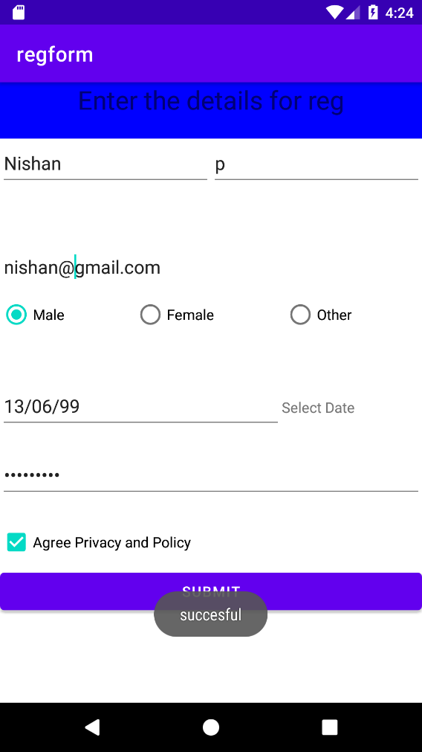

**COURSE OUTCOME 2**

**PROGRAM NO:**5

**DATE:**25/09/22

**INTENTS AND SHARED PREFERENCES**

**AIM**

Design a registration activity and store registration details in local memory of phone using Intents and SharedPreferences

**PAGE 1**

**XML CODE**

**<?xml version="1.0" encoding="utf-8"?>**

**<androidx.constraintlayout.widget.ConstraintLayout xmlns:android="http://schemas.android.com/apk/res/android"**

**xmlns:app="http://schemas.android.com/apk/res-auto"**

**xmlns:tools="http://schemas.android.com/tools"**

**android:layout_width="match_parent"**

**android:layout_height="match_parent"**

**tools:context=".MainActivity">**

**<LinearLayout**

**android:layout_width="409dp"**

**android:layout_height="729dp"**

**android:orientation="vertical"**

**tools:layout_editor_absoluteX="1dp"**

**tools:layout_editor_absoluteY="1dp"**

**android:gravity="center_horizontal">**

**<TextView**

**android:id="@+id/textView"**

**android:layout_width="150pt"**

**android:layout_height="50dp"**

**android:text="LOGIN"**

**android:textSize="34sp"**

**android:backgroundTint="@color/black"**

**android:gravity="center_horizontal"**

**/>**

**<EditText**

**android:id="@+id/e1"**

**android:layout_width="150pt"**

**android:layout_height="50dp"**

**android:ems="10"**

**android:inputType="textPersonName"**

**android:text=""**

**android:hint="Username"/>**

**<EditText**

**android:id="@+id/e2"**

**android:layout_width="150pt"**

**android:layout_height="50dp"**

**android:ems="10"**

**android:inputType="textPersonName"**

**android:text=""**

**android:hint="Email"/>**

**<EditText**

**android:id="@+id/e3"**

**android:layout_width="150pt"**

**android:layout_height="50dp"**

**android:ems="10"**

**android:text=""**

**android:hint="Password"**

**android:inputType="textPassword" />**

**<Button**

**android:id="@+id/button"**

**android:layout_width="100dp"**

**android:layout_height="wrap_content"**

**android:text="Log In"**

**android:backgroundTint="@color/black"**

**android:layout_margin="100dp"**

**android:onClick="LOGIN"/>**

**</LinearLayout>**

**</androidx.constraintlayout.widget.ConstraintLayout>**

**JAVA CODE**

package com.example.intentandsharedpreference;

import androidx.appcompat.app.AppCompatActivity;

import android.content.Intent;

import android.content.SharedPreferences;

import android.os.Bundle;

import android.view.View;

import android.widget.Button;

import android.widget.EditText;

import android.widget.Toast;

public class MainActivity extends AppCompatActivity {

EditText un,em,pw;

Button lg;

SharedPreferences sp;

@Override

protected void onCreate(Bundle savedInstanceState) {

super.onCreate(savedInstanceState);

setContentView(R.layout.activity_main);

un = findViewById(R.id.e1);

em = findViewById(R.id.e2);

pw = findViewById(R.id.e3);

lg = findViewById(R.id.button);

sp = getSharedPreferences("login",MODE_PRIVATE);

}

public void LOGIN(View view) {

Toast.makeText(this, "Successfully Login ", Toast.LENGTH_SHORT).show();

Intent i = new Intent(MainActivity.this,MainActivity2.class);

String name=un.getText().toString();

String email=em.getText().toString();

String password = pw.getText().toString();

i.putExtra("name",name);

i.putExtra("email",email);

SharedPreferences.Editor ed=sp.edit();

ed.putString("password",password);

ed.commit();

startActivity(i);

}

}

**PAGE 2**

**XML CODE**

**<?xml version="1.0" encoding="utf-8"?>**

**<androidx.constraintlayout.widget.ConstraintLayout xmlns:android="http://schemas.android.com/apk/res/android"**

**xmlns:app="http://schemas.android.com/apk/res-auto"**

**xmlns:tools="http://schemas.android.com/tools"**

**android:layout_width="match_parent"**

**android:layout_height="match_parent"**

**tools:context=".MainActivity2">**

**<LinearLayout**

**android:layout_width="409dp"**

**android:layout_height="729dp"**

**android:gravity="center_horizontal"**

**android:orientation="vertical"**

**tools:layout_editor_absoluteX="1dp"**

**tools:layout_editor_absoluteY="1dp">**

**<TextView**

**android:id="@+id/a"**

**android:layout_width="150pt"**

**android:layout_height="50dp"**

**android:layout_margin="50dp"**

**android:gravity="center"**

**android:text="Login Details"**

**android:textSize="24sp" />**

**<TextView**

**android:id="@+id/name"**

**android:layout_width="150pt"**

**android:layout_height="50dp"**

**android:gravity="center"**

**android:textSize="24sp" />**

**<TextView**

**android:id="@+id/email"**

**android:layout_width="150pt"**

**android:layout_height="50dp"**

**android:gravity="center"**

**android:textSize="24sp" />**

**<TextView**

**android:id="@+id/password"**

**android:layout_width="150pt"**

**android:layout_height="50dp"**

**android:gravity="center"**

**android:textSize="24sp" />**

**</LinearLayout>**

**</androidx.constraintlayout.widget.ConstraintLayout>**

**JAVA CODE**

package com.example.intentandsharedpreference;

import androidx.appcompat.app.AppCompatActivity;

import android.content.Intent;

import android.content.SharedPreferences;

import android.os.Bundle;

import android.widget.EditText;

import android.widget.TextView;

public class MainActivity2 extends AppCompatActivity {

    TextView un,em,pw;

    SharedPreferences sp;

    @Override

    protected void onCreate(Bundle savedInstanceState) {

        super.onCreate(savedInstanceState);

        setContentView(R.layout.activity_main2);

        un = findViewById(R.id.name);

        em = findViewById(R.id.email);

        pw = findViewById(R.id.password);

        sp = getSharedPreferences("login",MODE_PRIVATE);

        String s1 = sp.getString("password","");

        Intent i = getIntent();

        String name = i.getStringExtra("name");

        String email = i.getStringExtra("email");

        un.setText("NAME:"+name);

        em.setText("EMAIL:"+email);

        pw.setText("PASSWORD:"+s1);

    }

}

**OUTPUT**

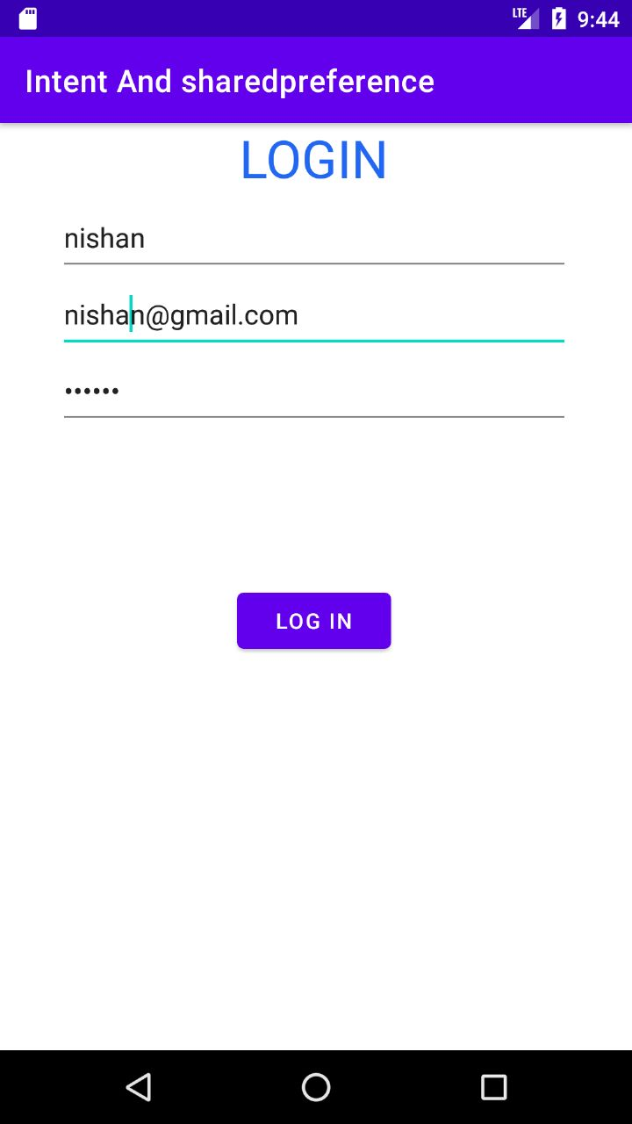 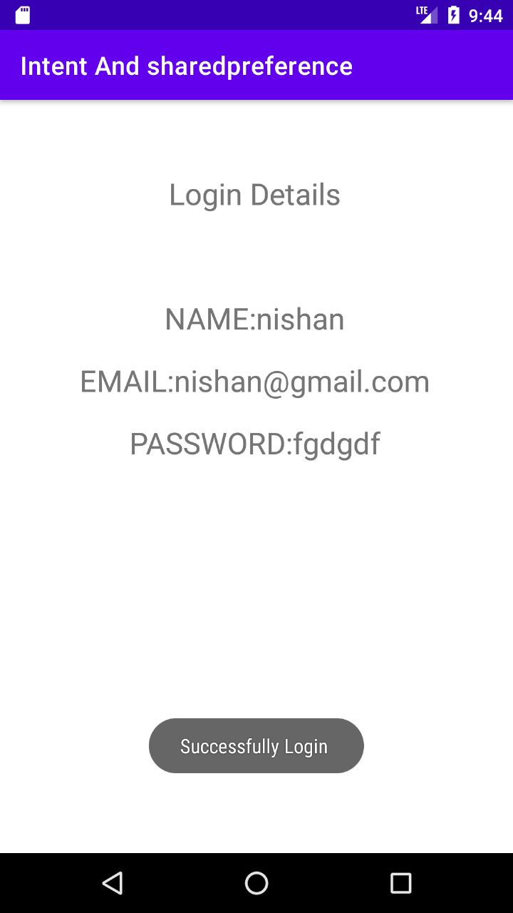

**PROGRAM NO:**6

**DATE:**30/09/22

**GRID CALCULATOR**

**AIM**

Design a simple Calculator using GridLayout and Cascaded LinearLayout

**XML CODE**

*<?*xml version="1.0" encoding="utf-8"*?>*<LinearLayout xmlns:android="http://schemas.android.com/apk/res/android"  
 xmlns:app="http://schemas.android.com/apk/res-auto"  
 xmlns:tools="http://schemas.android.com/tools"  
 android:layout_width="match_parent"  
 android:layout_height="match_parent"  
 android:orientation="vertical"  
 tools:context=".MainActivity">  
  
 <EditText  
 android:id="@+id/display"  
 android:layout_width="390dp"  
 android:layout_height="80dp"  
 android:layout_gravity="center"  
 android:layout_marginTop="30dp"  
 android:background="#393131"  
 android:gravity="center"  
 android:inputType="textPersonName"  
 android:textSize="48sp" />  
  
 <androidx.gridlayout.widget.GridLayout  
 android:layout_width="wrap_content"  
 android:layout_height="wrap_content"  
 android:layout_marginTop="30dp"  
 android:layout_gravity="center">  
  
 <Button  
 android:id="@+id/b7"  
 android:layout_width="wrap_content"  
 android:layout_height="54dp"  
 android:backgroundTint="#6e7778"  
 android:text="7"  
 app:layout_column="0"  
 app:layout_row="0" />  
 <Button  
 android:id="@+id/b8"  
 android:layout_width="wrap_content"  
 android:layout_height="54dp"  
 android:layout_marginLeft="10dp"  
 android:backgroundTint="#6e7778"  
 android:text="8"  
 app:layout_column="1"  
 app:layout_row="0" />  
 <Button  
 android:id="@+id/b9"  
 android:layout_width="wrap_content"  
 android:layout_height="54dp"  
 android:layout_marginLeft="10dp"  
 android:backgroundTint="#6e7778"  
 android:text="9"  
 app:layout_column="2"  
 app:layout_row="0" />  
 <Button  
 android:id="@+id/div"  
 android:layout_width="wrap_content"  
 android:layout_height="54dp"  
 android:layout_marginLeft="10dp"  
 android:backgroundTint="#3C393B"  
 android:text="/"  
 app:layout_column="3"  
 app:layout_row="0" />  
 <Button  
 android:id="@+id/b4"  
 android:layout_width="wrap_content"  
 android:layout_height="54dp"  
 android:backgroundTint="#6e7778"  
 android:text="4"  
 app:layout_column="0"  
 app:layout_row="1" />  
 <Button  
 android:id="@+id/b5"  
 android:layout_width="wrap_content"  
 android:layout_height="54dp"  
 android:layout_marginLeft="10dp"  
 android:backgroundTint="#6e7778"  
 android:text="5"  
 app:layout_column="1"  
 app:layout_row="1" />  
 <Button  
 android:id="@+id/b6"  
 android:layout_width="wrap_content"  
 android:layout_height="54dp"  
 android:layout_marginLeft="10dp"  
 android:backgroundTint="#6e7778"  
 android:text="6"  
 app:layout_column="2"  
 app:layout_row="1" />  
 <Button  
 android:id="@+id/mul"  
 android:layout_width="wrap_content"  
 android:layout_height="54dp"  
 android:layout_marginLeft="10dp"  
 android:backgroundTint="#3C393B"  
 android:text="x"  
 app:layout_column="3"  
 app:layout_row="1" />  
 <Button  
 android:id="@+id/b1"  
 android:layout_width="wrap_content"  
 android:layout_height="54dp"  
 android:backgroundTint="#6e7778"  
 android:text="1"  
 app:layout_column="0"  
 app:layout_row="2" />  
 <Button  
 android:id="@+id/b2"  
 android:layout_width="wrap_content"  
 android:layout_height="54dp"  
 android:layout_marginLeft="10dp"  
 android:backgroundTint="#6e7778"  
 android:text="2"  
 app:layout_column="1"  
 app:layout_row="2" />  
 <Button  
 android:id="@+id/b3"  
 android:layout_width="wrap_content"  
 android:layout_height="54dp"  
 android:layout_marginLeft="10dp"  
 android:backgroundTint="#6e7778"  
 android:text="3"  
 app:layout_column="2"  
 app:layout_row="2" />  
 <Button  
 android:id="@+id/sub"  
 android:layout_width="wrap_content"  
 android:layout_height="54dp"  
 android:layout_marginLeft="10dp"  
 android:backgroundTint="#3C393B"  
 android:text="-"  
 app:layout_column="3"  
 app:layout_row="2" />  
 <Button  
 android:id="@+id/clr"  
 android:layout_width="wrap_content"  
 android:layout_height="54dp"  
 android:backgroundTint="#3C393B"  
 android:text="clr"  
 app:layout_column="0"  
 app:layout_row="3" />  
 <Button  
 android:id="@+id/b0"  
 android:layout_width="wrap_content"  
 android:layout_height="54dp"  
 android:layout_marginLeft="10dp"  
 android:backgroundTint="#6e7778"  
 android:text="0"  
 app:layout_column="1"  
 app:layout_row="3" />  
 <Button  
 android:id="@+id/equal"  
 android:layout_width="wrap_content"  
 android:layout_height="54dp"  
 android:layout_marginLeft="10dp"  
 android:backgroundTint="#3C393B"  
 android:text="="  
 app:layout_column="2"  
 app:layout_row="3" />  
 <Button  
 android:id="@+id/add"  
 android:layout_width="wrap_content"  
 android:layout_height="54dp"  
 android:layout_marginLeft="10dp"  
 android:backgroundTint="#3C393B"  
 android:text="+"  
 app:layout_column="3"  
 app:layout_row="3" />  
 </androidx.gridlayout.widget.GridLayout>  
</LinearLayout>

**JAVA CODE**

package com.example.calculator;  
  
import androidx.appcompat.app.AppCompatActivity;  
  
import android.os.Bundle;  
import android.view.View;  
import android.widget.Button;  
import android.widget.EditText;  
  
public class MainActivity extends AppCompatActivity implements View.OnClickListener {  
 EditText number;  
 double num1=0;  
 double num2=0;  
 String op="";  
 Button b1, b2, b3, b4, b5, b6, b7, b8, b9, b0, sum, sub, mul, div,equal, clear;  
  
 @Override  
 protected void onCreate(Bundle savedInstanceState) {  
 super.onCreate(savedInstanceState);  
 setContentView(R.layout.*activity_main*);  
  
 number = findViewById(R.id.*display*);  
 b0 = findViewById(R.id.*b0*);  
 b1 = findViewById(R.id.*b1*);  
 b2 = findViewById(R.id.*b2*);  
 b3 = findViewById(R.id.*b3*);  
 b4 = findViewById(R.id.*b4*);  
 b5 = findViewById(R.id.*b5*);  
 b6 = findViewById(R.id.*b6*);  
 b7 = findViewById(R.id.*b7*);  
 b8 = findViewById(R.id.*b8*);  
 b9 = findViewById(R.id.*b9*);  
  
 sum = findViewById(R.id.*add*);  
 sub = findViewById(R.id.*sub*);  
 mul = findViewById(R.id.*mul*);  
 div = findViewById(R.id.*div*);  
 equal = findViewById(R.id.*equal*);  
 clear = findViewById(R.id.*clr*);  
  
 b0.setOnClickListener(this);  
 b1.setOnClickListener(this);  
 b2.setOnClickListener(this);  
 b3.setOnClickListener(this);  
 b4.setOnClickListener(this);  
  
 b5.setOnClickListener(this);  
 b6.setOnClickListener(this);  
 b7.setOnClickListener(this);  
 b8.setOnClickListener(this);  
 b9.setOnClickListener(this);  
  
 mul.setOnClickListener(this);  
 div.setOnClickListener(this);  
 sub.setOnClickListener(this);  
 sum.setOnClickListener(this);  
 clear.setOnClickListener(this);  
 equal.setOnClickListener(this);  
 }  
  
 @Override  
 public void onClick(View view) {  
 Button b = (Button) view;  
 if (view == clear) {  
 number.setText("");  
 } else if (view == sub || view == sum || view == mul || view == div) {  
 num1 = Integer.*parseInt*(number.getText().toString());  
 op = b.getText().toString();  
 number.setText("");  
 } else if (view == equal) {  
 num2 = Integer.*parseInt*(number.getText().toString());  
 if (op.equals("+")) {  
 number.setText(num1 + num2 + "");  
 } else if (op.equals("-")) {  
 number.setText(num1 - num2 + "");  
 } else if (op.equals("x")) {  
 number.setText(num1 * num2 + "");  
 } else if (op.equals("/")) {  
 number.setText(num1 / num2 + "");  
 }  
 } else {  
 String s = number.getText().toString();  
 number.setText(s + b.getText().toString());  
 }  
 }  
}

**OUTPUT**

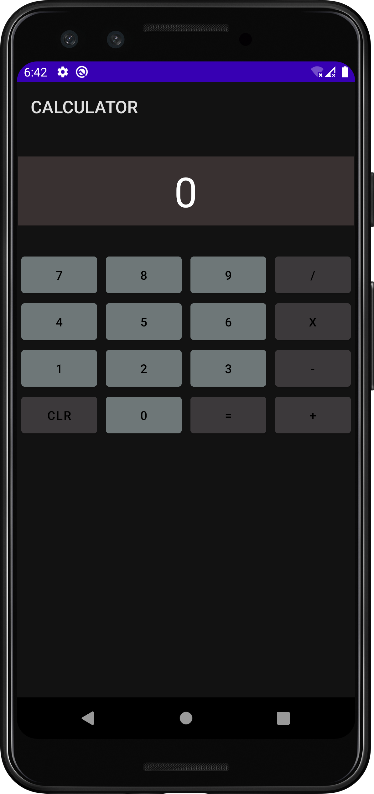

**PROGRAM NO:**7

**DATE:**05/10/22

**FACEBOOK PAGE**

**AIM**

Create a Facebook page using RelativeLayout; set properties using .xml file

**XML CODE**

*<?*xml version="1.0" encoding="utf-8"*?>*<RelativeLayout xmlns:android="http://schemas.android.com/apk/res/android" xmlns:app="http://schemas.android.com/apk/res-auto"  
 xmlns:tools="http://schemas.android.com/tools"  
 android:layout_width="match_parent"  
 android:layout_height="match_parent"  
 android:background="#3e52ab"  
 tools:context=".MainActivity">  
  
 <ImageView  
 android:id="@+id/imageView"  
 android:layout_width="match_parent"  
 android:layout_height="100dp"  
 android:layout_gravity="center"  
 android:layout_marginTop="40dp"  
 app:srcCompat="@drawable/fb2" />  
  
 <EditText  
 android:id="@+id/username"  
 android:layout_width="match_parent"  
 android:layout_height="50dp"  
 android:layout_below="@+id/imageView"  
 android:layout_marginLeft="10dp"  
 android:layout_marginRight="10dp"  
 android:layout_marginTop="60dp"  
 android:background="@xml/back"  
 android:ems="10"  
 android:hint="Email or Phone Number"  
 android:inputType="textPersonName"  
 android:paddingLeft="30dp"  
 android:textColor="@color/white"  
 android:textColorHint="@color/white"  
 android:textSize="19sp" />  
  
 <EditText  
 android:id="@+id/password"  
 android:layout_width="match_parent"  
 android:layout_height="50dp"  
 android:layout_below="@+id/username"  
 android:layout_marginLeft="10dp"  
 android:layout_marginTop="10dp"  
 android:layout_marginRight="10dp"  
 android:background="@xml/back"  
 android:ems="10"  
 android:hint="password"  
 android:inputType="textPersonName"  
 android:paddingLeft="30dp"  
 android:textColor="@color/white"  
 android:textColorHint="@color/white"  
 android:textSize="19sp" />  
  
 <Button  
 android:id="@+id/button"  
 android:layout_width="260dp"  
 android:layout_height="55dp"  
 android:layout_below="@+id/password"  
 android:layout_centerHorizontal="true"  
 android:layout_marginTop="40dp"  
 android:backgroundTint="#46b082"  
 android:text="Login"  
 android:textColor="#FFFFFF"  
 android:textSize="18sp" />  
  
 <TextView  
 android:id="@+id/textView"  
 android:layout_width="wrap_content"  
 android:layout_height="wrap_content"  
 android:layout_below="@id/button"  
 android:layout_centerHorizontal="true"  
 android:layout_marginTop="15dp"  
 android:text="Forgot account?"  
 android:textColor="@color/white"  
 android:textSize="22dp" />  
  
 <View  
 android:layout_width="match_parent"  
 android:layout_height="2dp"  
 android:layout_below="@+id/textView"  
 android:layout_marginTop="20dp"  
 android:background="#94918e" />  
  
 <Button  
 android:id="@+id/button2"  
 android:layout_width="260dp"  
 android:layout_height="55dp"  
 android:layout_below="@+id/textView"  
 android:layout_centerHorizontal="true"  
 android:layout_marginTop="70dp"  
 android:backgroundTint="#46b082"  
 android:text="Create New Account"  
 android:textColor="#FFFFFF" />  
</RelativeLayout>

*<?*xml version="1.0" encoding="utf-8"*?>*<shape xmlns:android="http://schemas.android.com/apk/res/android"  
android:shape="rectangle" >  
  
*<!-- View background color -->*<solid  
 android:color="#3e52ab" >  
</solid>  
  
*<!-- View border color and width -->*<stroke  
 android:width="1dp"  
 android:color="@color/white" >  
</stroke>  
  
*<!-- The radius makes the corners rounded -->*<corners  
 android:radius="4dp" >  
</corners>  
  
</shape>

**OUTPUT**

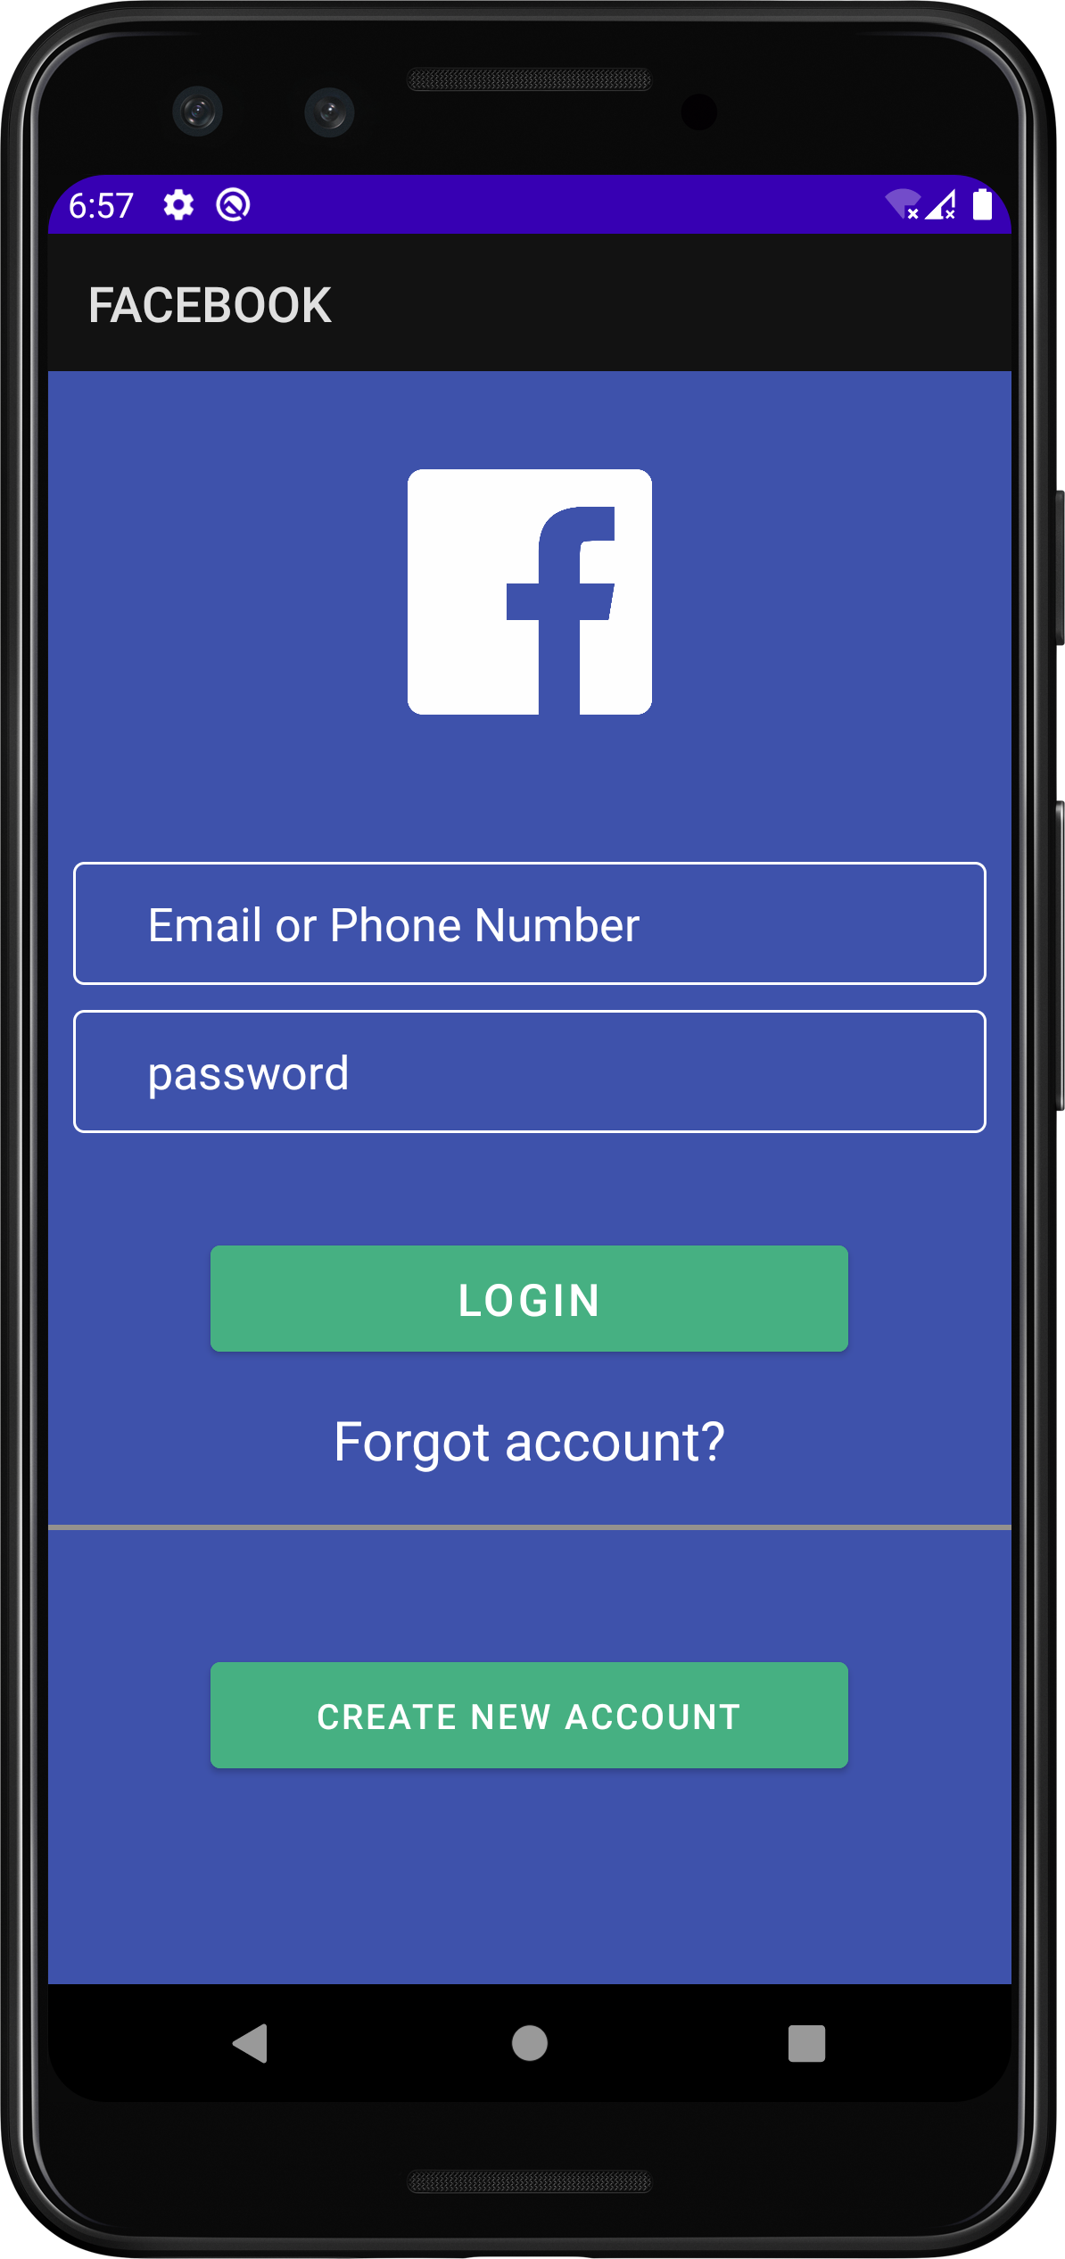

**PROGRAM NO:**8

**DATE:**20/10/22

**TOGGLE IMAGE**

**AIM**

Develop an application that toggles image using FrameLayout

**XML CODE**

*<?*xml version="1.0" encoding="utf-8"*?>*<androidx.constraintlayout.widget.ConstraintLayout xmlns:android="http://schemas.android.com/apk/res/android"  
 xmlns:app="http://schemas.android.com/apk/res-auto"  
 xmlns:tools="http://schemas.android.com/tools"  
 android:layout_width="match_parent"  
 android:layout_height="match_parent"  
  
 tools:context=".MainActivity">  
  
 <LinearLayout  
 android:layout_width="409dp"  
 android:layout_height="729dp"  
 android:orientation="horizontal"  
 tools:layout_editor_absoluteX="1dp"  
 tools:layout_editor_absoluteY="1dp"  
 tools:ignore="MissingConstraints">  
  
 <ImageView  
 android:id="@+id/img1"  
 android:layout_width="wrap_content"  
 android:layout_height="74dp"  
 android:layout_weight="1"  
 android:src="@drawable/pikachu"  
 app:srcCompat="@android:drawable/btn_star_big_on" />  
  
 <ImageView  
 android:id="@+id/img2"  
 android:layout_width="wrap_content"  
 android:layout_height="72dp"  
 android:layout_weight="1"  
 android:src="@drawable/a"  
 app:srcCompat="@android:drawable/checkbox_on_background" />  
 </LinearLayout>  
</androidx.constraintlayout.widget.ConstraintLayout>

**JAVA CODE**

package com.example.toggle;  
  
import androidx.appcompat.app.AppCompatActivity;  
  
import android.os.Bundle;  
import android.view.View;  
import android.widget.ImageView;  
  
public class MainActivity extends AppCompatActivity implements View.OnClickListener {  
 ImageView img,img1;  
 @Override  
 protected void onCreate(Bundle savedInstanceState) {  
 super.onCreate(savedInstanceState);  
 setContentView(R.layout.*activity_main*);  
 img =(ImageView) findViewById(R.id.*img1*);  
 img1 =(ImageView) findViewById(R.id.*img2*);  
  
 img.setOnClickListener(this);  
 img1.setOnClickListener(this);  
 }  
  
 @Override  
 public void onClick(View view) {  
 if (view == img){  
 img.setVisibility(View.*GONE*);  
 img1.setVisibility(View.*VISIBLE*);  
 }  
 else {  
 img1.setVisibility(View.*GONE*);  
 img.setVisibility(View.*VISIBLE*);  
  
 }  
 }  
}

**OUTPUT**

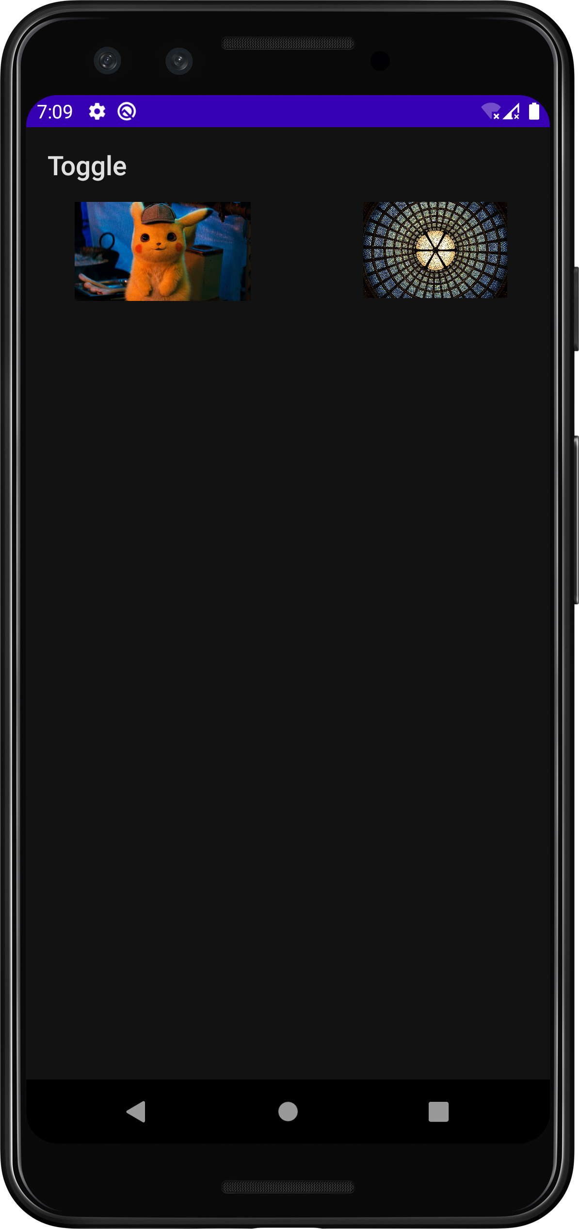 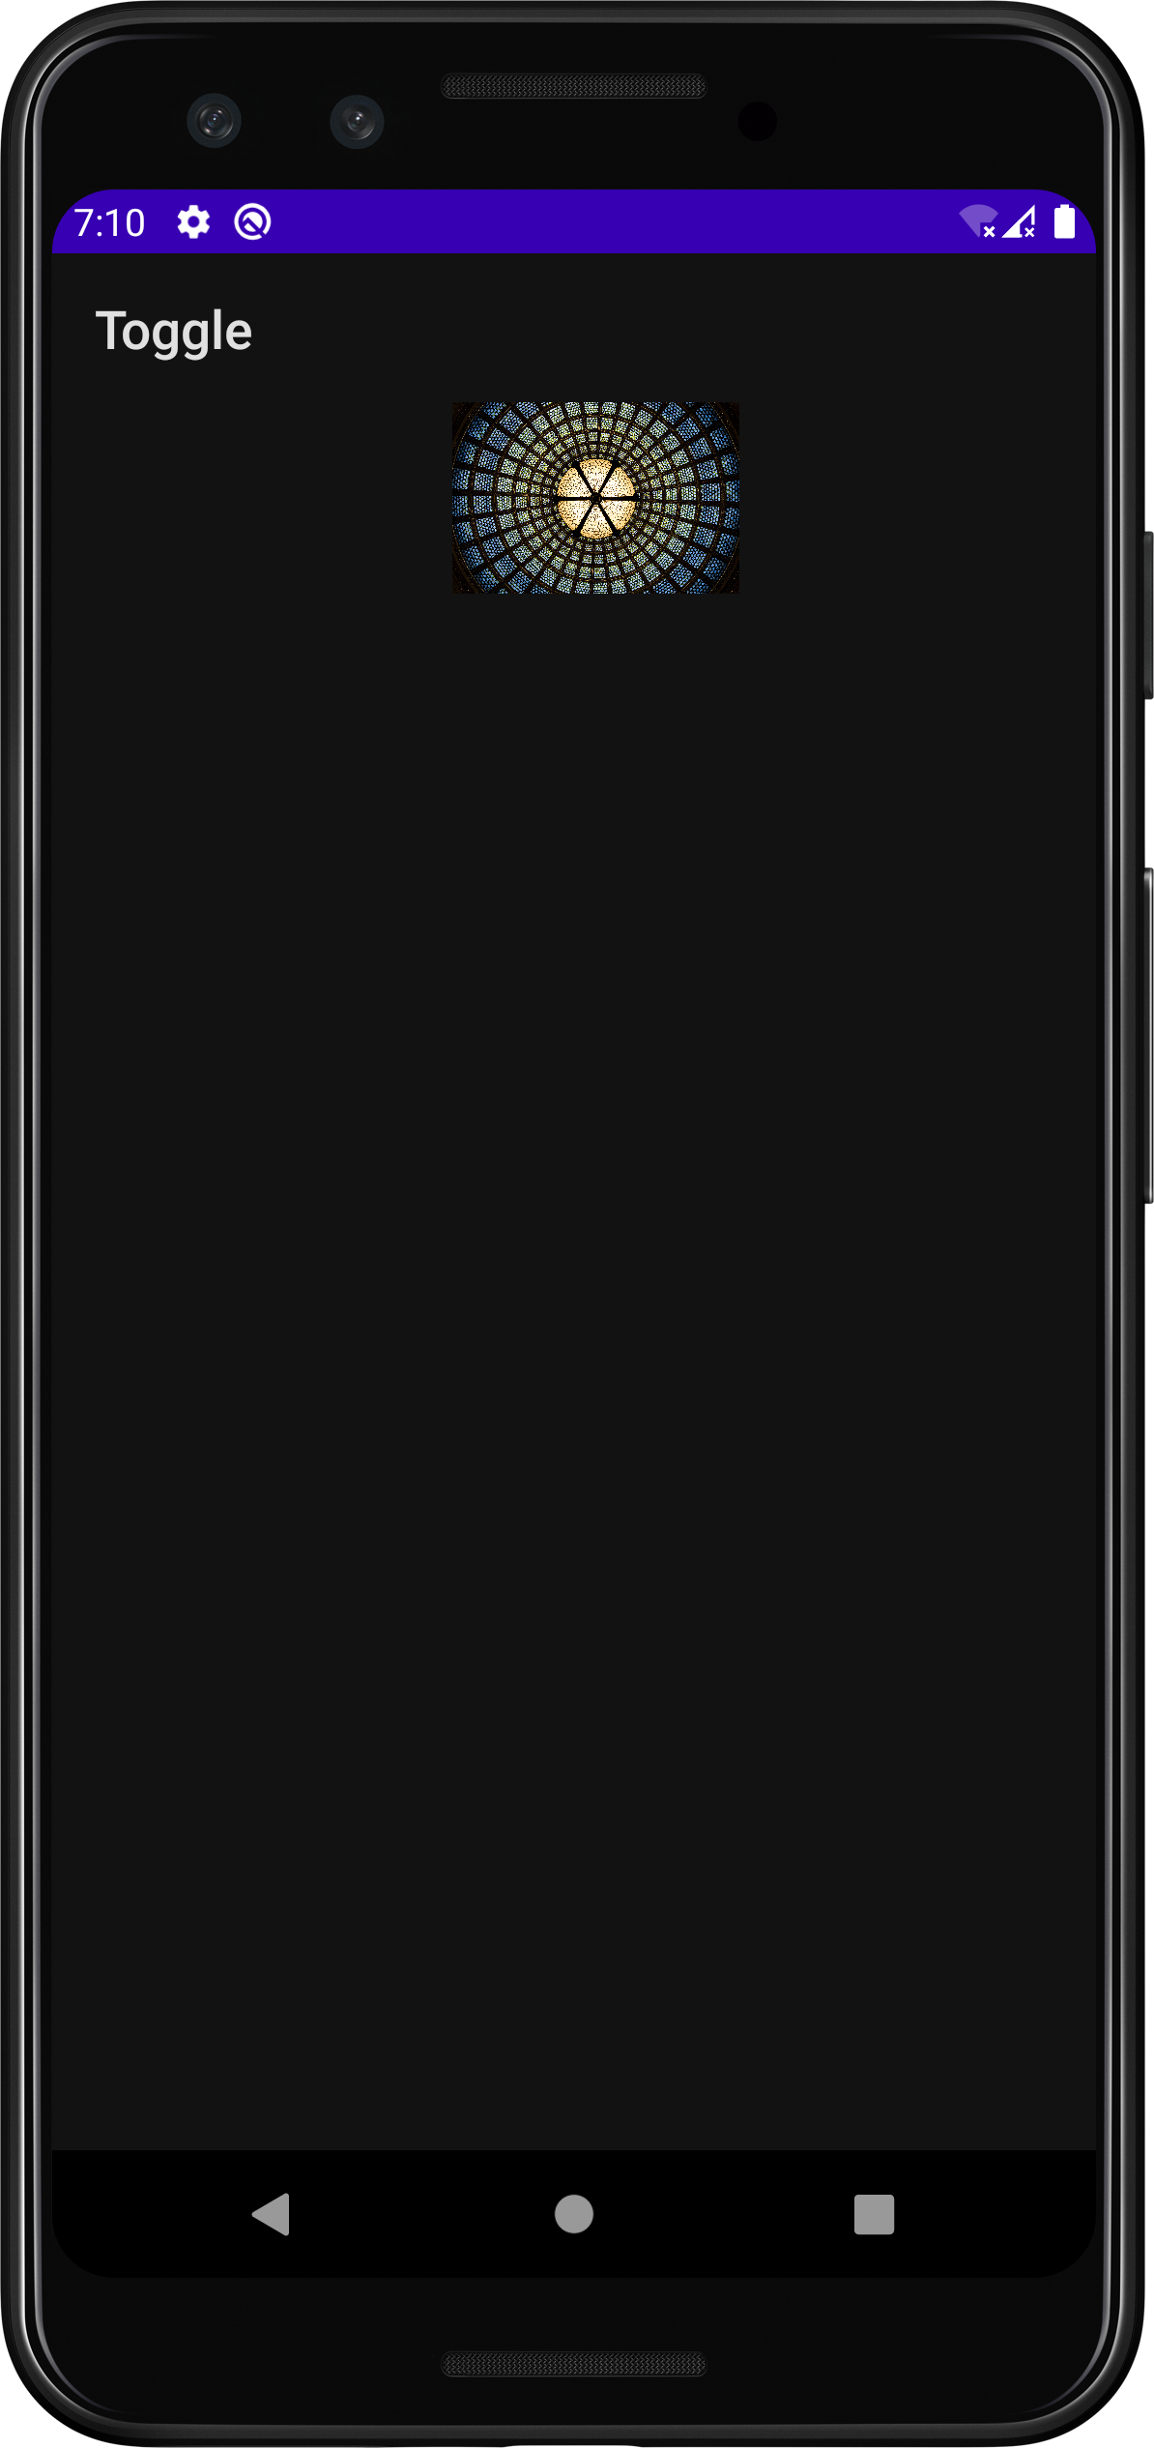 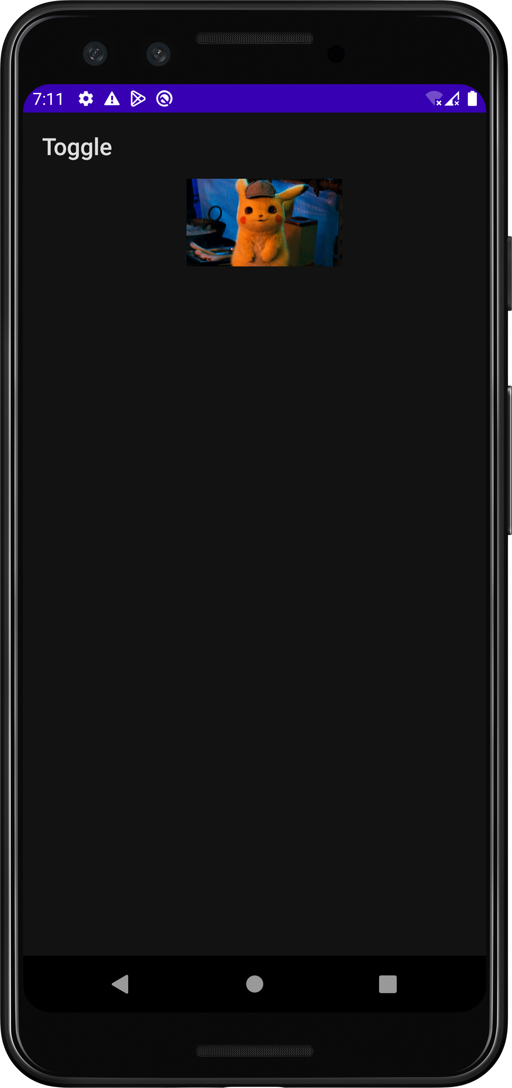

**COURSE OUTCOME 3**

**PROGRAM NO:**9

**DATE:**30/10/22

**INTENT**

**AIM**

Implement Intent to navigate between multiple activities

**PAGE 1**

**XML CODE**

*<?*xml version="1.0" encoding="utf-8"*?>*<androidx.constraintlayout.widget.ConstraintLayout xmlns:android="http://schemas.android.com/apk/res/android"  
 xmlns:app="http://schemas.android.com/apk/res-auto"  
 xmlns:tools="http://schemas.android.com/tools"  
 android:layout_width="match_parent"  
 android:layout_height="match_parent"  
 tools:context=".MainActivity">  
  
 <Button  
 android:id="@+id/button"  
 android:layout_width="wrap_content"  
 android:layout_height="wrap_content"  
 android:onClick="click"  
 android:text="NEXT PAGE"  
 tools:ignore="MissingConstraints"  
 tools:layout_editor_absoluteX="147dp"  
 tools:layout_editor_absoluteY="41dp" />  
</androidx.constraintlayout.widget.ConstraintLayout>

**JAVA CODE**

package com.example.intent;  
  
import androidx.appcompat.app.AppCompatActivity;  
  
import android.content.Intent;  
import android.os.Bundle;  
import android.view.View;  
import android.widget.Button;  
  
public class MainActivity extends AppCompatActivity {  
 Button b1;  
 @Override  
 protected void onCreate(Bundle savedInstanceState) {  
 super.onCreate(savedInstanceState);  
 setContentView(R.layout.*activity_main*);  
 b1=findViewById(R.id.*button*);  
 }  
  
 public void click(View view) {  
 Intent i=new Intent(MainActivity.this,MainActivity2.class);  
 startActivity(i);  
 }  
}

**PAGE 2**

**XML CODE**

*<?*xml version="1.0" encoding="utf-8"*?>*<androidx.constraintlayout.widget.ConstraintLayout xmlns:android="http://schemas.android.com/apk/res/android"  
 xmlns:app="http://schemas.android.com/apk/res-auto"  
 xmlns:tools="http://schemas.android.com/tools"  
 android:layout_width="match_parent"  
 android:layout_height="match_parent"  
 tools:context=".MainActivity2">  
  
 <Button  
 android:id="@+id/button2"  
 android:layout_width="wrap_content"  
 android:layout_height="wrap_content"  
 android:onClick="click"  
 android:text="PREVIOUS PAGE"  
 tools:layout_editor_absoluteX="129dp"  
 tools:layout_editor_absoluteY="54dp"  
 tools:ignore="MissingConstraints" />  
</androidx.constraintlayout.widget.ConstraintLayout>

**JAVA CODE**

package com.example.intent;  
  
import androidx.appcompat.app.AppCompatActivity;  
  
import android.content.Intent;  
import android.os.Bundle;  
import android.view.View;  
  
public class MainActivity2 extends AppCompatActivity {  
  
 @Override  
 protected void onCreate(Bundle savedInstanceState) {  
 super.onCreate(savedInstanceState);  
 setContentView(R.layout.*activity_main2*);  
 }  
  
 public void click(View view) {  
 Intent i=new Intent(MainActivity2.this,MainActivity.class);  
 startActivity(i);  
 }  
}

**OUTPUT**

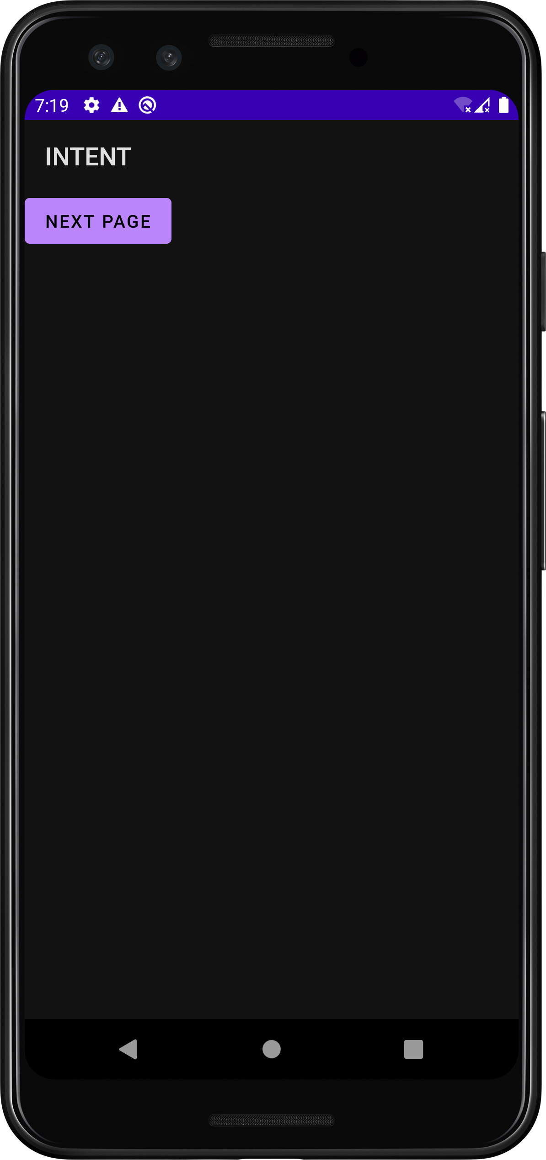 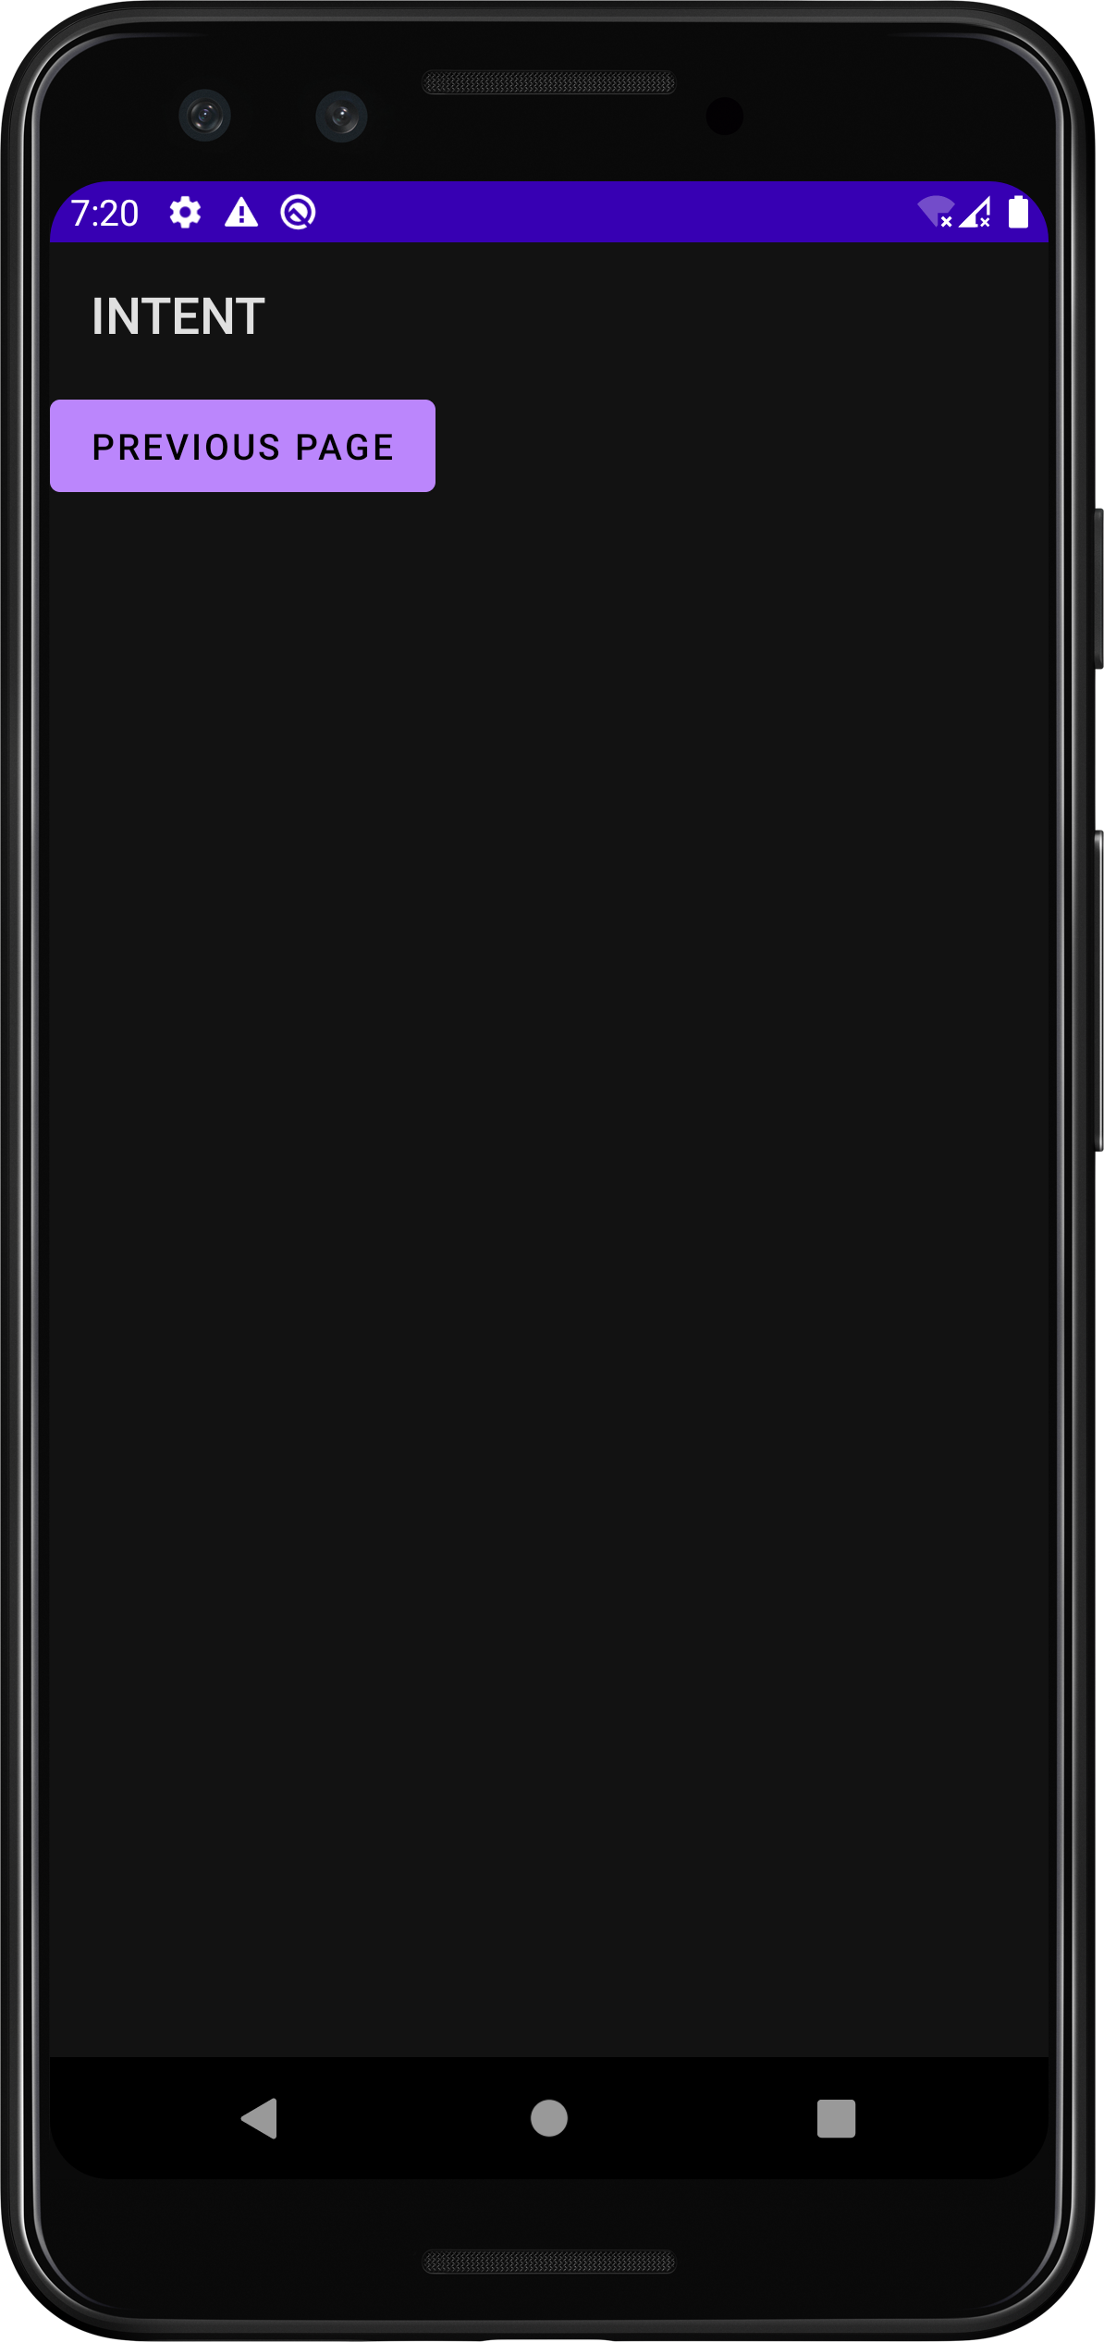

**PROGRAM NO:**10

**DATE:**10/11/22

**MENU**

**AIM**

Implement Options Menu to navigate to activities

**MENU**

*<?*xml version="1.0" encoding="utf-8"*?>*<menu xmlns:app="http://schemas.android.com/apk/res-auto"  
 xmlns:android="http://schemas.android.com/apk/res/android">  
  
 <item  
 android:id="@+id/i1"  
 android:title="STUDENTS" />  
 <item  
 android:id="@+id/i2"  
 android:title="DEPARTMENT">  
 <menu>  
 <item  
 android:id="@+id/s1"  
 android:title="MCA" />  
 <item  
 android:id="@+id/s2"  
 android:title="MBA" />  
 <item  
 android:id="@+id/s3"  
 android:title="B-TECH" />  
 </menu>  
 </item>  
 <item  
 android:id="@+id/i3"  
 android:title="MANAGEMENT" />  
</menu>

**XML CODE**

*<?*xml version="1.0" encoding="utf-8"*?>*<androidx.constraintlayout.widget.ConstraintLayout xmlns:android="http://schemas.android.com/apk/res/android"  
 xmlns:app="http://schemas.android.com/apk/res-auto"  
 xmlns:tools="http://schemas.android.com/tools"  
 android:layout_width="match_parent"  
 android:layout_height="match_parent"  
 tools:context=".MainActivity">  
  
 <TextView  
 android:layout_width="wrap_content"  
 android:layout_height="wrap_content"  
 android:text="MENU"  
 app:layout_constraintBottom_toBottomOf="parent"  
 app:layout_constraintEnd_toEndOf="parent"  
 app:layout_constraintStart_toStartOf="parent"  
 app:layout_constraintTop_toTopOf="parent" />  
  
</androidx.constraintlayout.widget.ConstraintLayout>

**JAVA CODE**

package com.example.menu;  
  
import androidx.appcompat.app.AppCompatActivity;  
  
import android.os.Bundle;  
import android.view.Menu;  
import android.view.MenuInflater;  
import android.view.MenuItem;  
import android.widget.Toast;  
  
public class MainActivity extends AppCompatActivity {  
  
 @Override  
 protected void onCreate(Bundle savedInstanceState) {  
 super.onCreate(savedInstanceState);  
 setContentView(R.layout.*activity_main*);  
 }  
 public boolean onCreateOptionsMenu(Menu menu)  
 {  
 MenuInflater inflater = getMenuInflater();  
 inflater.inflate(R.menu.*samplemenu*,menu);  
 return true;  
 }  
 public boolean onOptionsItemSelected(MenuItem item){  
 switch(item.getItemId()){  
 case R.id.*i1*:  
 Toast.*makeText*(this,"STUDENTS",Toast.*LENGTH_LONG*).show();  
 *// Intent i=new Intent(this,MainActivity2.class);  
 // startActivity(i);* break;  
 case R.id.*i2*:  
 Toast.*makeText*(this,"DEPARTMENT",Toast.*LENGTH_LONG*).show();  
 break;  
 case R.id.*s1*:  
 Toast.*makeText*(this,"MCA",Toast.*LENGTH_LONG*).show();  
 break;  
 case R.id.*s2*:  
 Toast.*makeText*(this,"MBA",Toast.*LENGTH_LONG*).show();  
 break;  
 case R.id.*s3*:  
 Toast.*makeText*(this,"B-TECH",Toast.*LENGTH_LONG*).show();  
 break;  
 case R.id.*i3*:  
 Toast.*makeText*(this,"MANAGEMENT",Toast.*LENGTH_LONG*).show();  
 break;  
 }  
 return false;  
 }  
}

**OUTPUT**

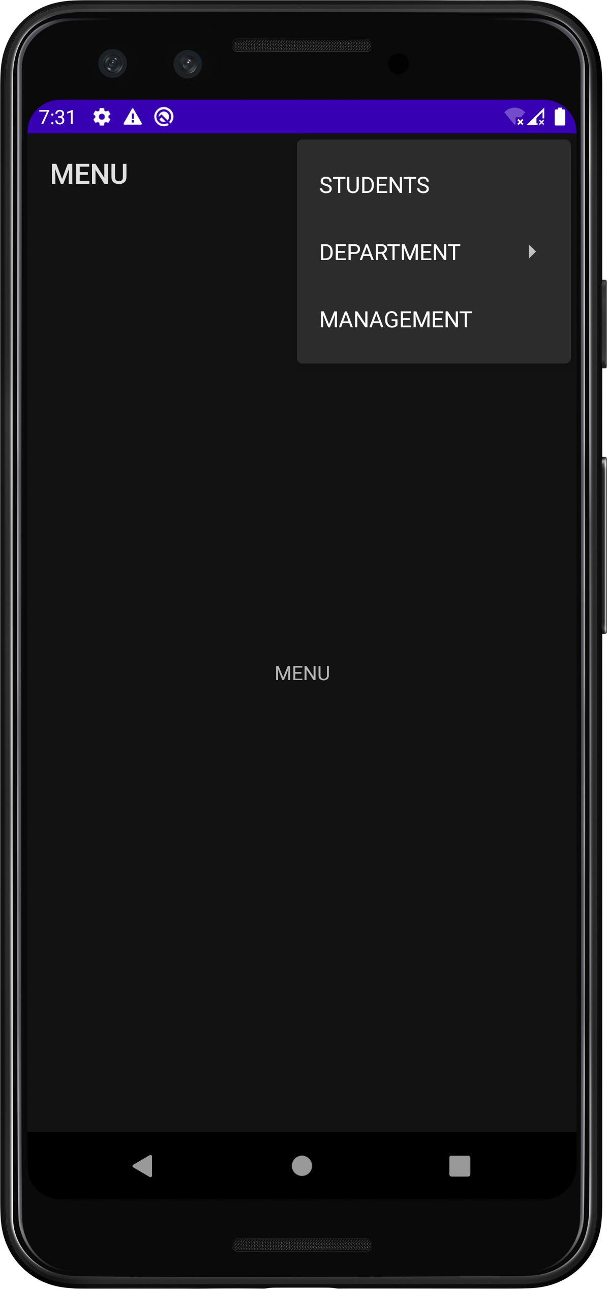 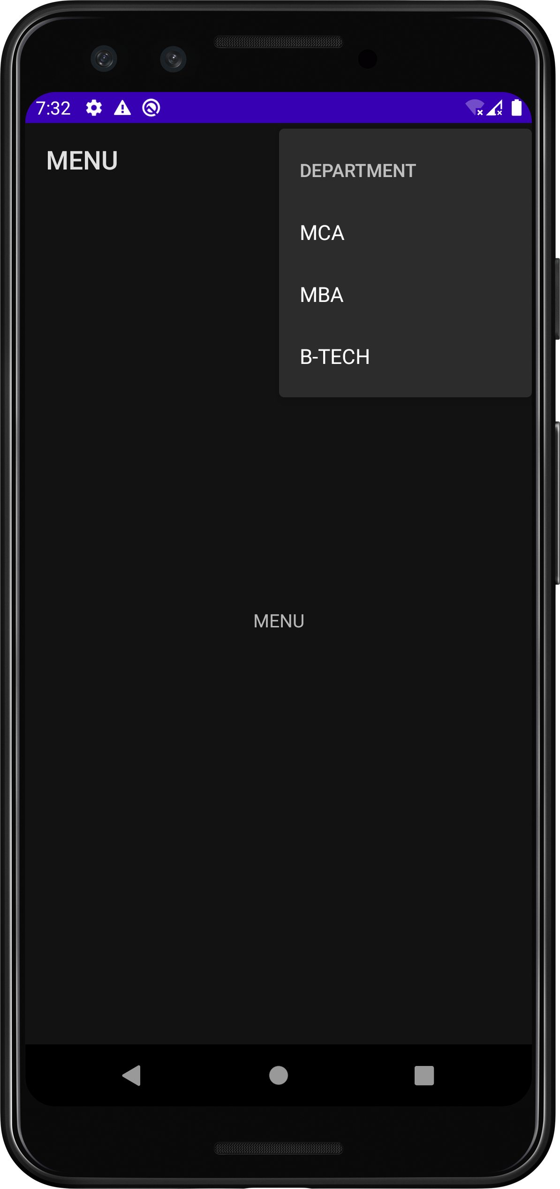

**COURSE OUTCOME 5**

**PROGRAM NO:**11

**DATE:2**0/11/22

**DATABASE MANAGEMENT**

**AIM**

Create database using SQLite and perform INSERT,SELECT,UPDATE AND DELETE

**XML CODE**

*<?*xml version="1.0" encoding="utf-8"*?>*<androidx.constraintlayout.widget.ConstraintLayout xmlns:android="http://schemas.android.com/apk/res/android"  
 xmlns:app="http://schemas.android.com/apk/res-auto"  
 xmlns:tools="http://schemas.android.com/tools"  
 android:layout_width="match_parent"  
 android:layout_height="match_parent"  
 tools:context=".MainActivity">  
  
 <LinearLayout  
 android:layout_width="407dp"  
 android:layout_height="739dp"  
 android:orientation="vertical"  
 tools:layout_editor_absoluteX="2dp"  
 tools:layout_editor_absoluteY="-4dp">  
  
 <TextView  
 android:id="@+id/textView"  
 android:layout_width="match_parent"  
 android:layout_height="47dp"  
 android:text="ID" />  
  
 <EditText  
 android:id="@+id/id"  
 android:layout_width="match_parent"  
 android:layout_height="wrap_content"  
 android:ems="10"  
 android:hint="Enter id"  
 android:inputType="textPersonName" />  
  
 <TextView  
 android:id="@+id/textView2"  
 android:layout_width="match_parent"  
 android:layout_height="40dp"  
 android:text="NAME" />  
  
 <EditText  
 android:id="@+id/name"  
 android:layout_width="match_parent"  
 android:layout_height="wrap_content"  
 android:ems="10"  
 android:hint="Enter name"  
 android:inputType="textPersonName" />  
  
 <TextView  
 android:id="@+id/textView3"  
 android:layout_width="match_parent"  
 android:layout_height="50dp"  
 android:text="PLACE" />  
  
 <EditText  
 android:id="@+id/place"  
 android:layout_width="match_parent"  
 android:layout_height="wrap_content"  
 android:ems="10"  
 android:hint="Enter your place"  
 android:inputType="textPersonName" />  
  
 <Button  
 android:id="@+id/insert"  
 android:layout_width="match_parent"  
 android:layout_height="wrap_content"  
 android:text="INSERT" />  
  
 <Button  
 android:id="@+id/select"  
 android:layout_width="match_parent"  
 android:layout_height="wrap_content"  
 android:text="SELECT" />  
  
 <Button  
 android:id="@+id/update"  
 android:layout_width="match_parent"  
 android:layout_height="wrap_content"  
 android:text="UPDATE" />  
  
 <Button  
 android:id="@+id/delete"  
 android:layout_width="match_parent"  
 android:layout_height="wrap_content"  
 android:text="DELETE" />  
  
 <Button  
 android:id="@+id/clear"  
 android:layout_width="match_parent"  
 android:layout_height="wrap_content"  
 android:text="CLEAR" />  
 </LinearLayout>  
</androidx.constraintlayout.widget.ConstraintLayout>

**JAVA CODE**

package com.example.co_5_database;  
  
import androidx.annotation.RequiresApi;  
import androidx.appcompat.app.AppCompatActivity;  
  
import android.app.AlertDialog;  
import android.database.Cursor;  
import android.database.sqlite.SQLiteDatabase;  
import android.os.Build;  
import android.os.Bundle;  
import android.view.View;  
import android.widget.Button;  
import android.widget.EditText;  
import android.widget.Toast;  
  
public class MainActivity extends AppCompatActivity {  
 EditText eid,ename,eplace;  
 Button bins,bsel,bup,bdel,bclr;  
 AlertDialog.Builder builder;  
 SQLiteDatabase db;  
 @RequiresApi(api = Build.VERSION_CODES.*ICE_CREAM_SANDWICH_MR1*)  
 @Override  
 protected void onCreate(Bundle savedInstanceState) {  
 super.onCreate(savedInstanceState);  
 setContentView(R.layout.*activity_main*);  
 eid = findViewById(R.id.*id*);  
 ename = findViewById(R.id.*name*);  
 eplace = findViewById(R.id.*place*);  
 bins = findViewById(R.id.*insert*);  
 bsel = findViewById(R.id.*select*);  
 bup = findViewById(R.id.*update*);  
 bdel = findViewById(R.id.*delete*);  
 bclr = findViewById(R.id.*clear*);  
 builder = new AlertDialog.Builder(this);  
  
 try{  
 db = openOrCreateDatabase("empdb",*MODE_PRIVATE*,null);  
 db.execSQL("create table employee(id integer primary key,name Text,place Text)");  
 Toast.*makeText*(getApplicationContext(),"Created Successffully",Toast.*LENGTH_SHORT*).show();  
 }  
 catch(Exception e){  
  
 }  
   
 bins.setOnClickListener(new View.OnClickListener() {  
 @Override  
 public void onClick(View view) {  
 try{  
 db.execSQL("insert into employee values("+eid.getText().toString()+",'"+ename.getText().toString()+"','"+eplace.getText().toString()+"')");  
 Toast.*makeText*(getApplicationContext(),"Record Inserted Successfully",Toast.*LENGTH_SHORT*).show();  
 }  
 catch(Exception e){  
 Toast.*makeText*(getApplicationContext(), "Error in Data", Toast.*LENGTH_SHORT*).show();  
 }  
 }  
 });  
  
 bclr.callOnClick();  
  
 bsel.setOnClickListener(new View.OnClickListener() {  
 @Override  
 public void onClick(View view) {  
 Cursor c = db.rawQuery("select * from employee", null);  
 if(c.getCount()==0){  
 Toast.*makeText*(getApplicationContext(), "No such Record!", Toast.*LENGTH_SHORT*).show();  
 }  
 else{  
 StringBuffer b = new StringBuffer();  
 while(c.moveToNext()){  
 b.append("ID : " + c.getString(0) + "\n");  
 b.append("NAME : " + c.getString(1) + "\n");  
 b.append("PLCE : " + c.getString(2) + "\n");  
 }  
 Toast.*makeText*(getApplicationContext(),b.toString(),Toast.*LENGTH_LONG*).show();  
 builder.setMessage(b.toString());  
 AlertDialog alert = builder.create();  
 alert.setTitle("---EMPLOYEE DATA---");  
 alert.show();  
 }  
 }  
 });  
  
 bup.setOnClickListener(new View.OnClickListener() {  
 @Override  
 public void onClick(View view) {  
 db.execSQL("update employee set name='"+ename.getText().toString()+"',place='"+eplace.getText().toString()+"' where id="+eid.getText().toString()+"");  
 Toast.*makeText*(getApplicationContext(), "---Updated---", Toast.*LENGTH_SHORT*).show();  
 }  
 });  
  
 bdel.setOnClickListener(new View.OnClickListener() {  
 @Override  
 public void onClick(View view) {  
 db.execSQL("delete from employee where id="+eid.getText().toString());  
 Toast.*makeText*(getApplicationContext(), "---Item Deleted---", Toast.*LENGTH_SHORT*).show();  
 }  
 });  
  
 bclr.setOnClickListener(new View.OnClickListener() {  
 @Override  
 public void onClick(View view) {  
 eid.setText("");  
 ename.setText("");  
 eplace.setText("");  
 }  
 });  
 bclr.callOnClick();  
 }  
}

**OUTPUT**

